Tan, Eli Edrian Lui

Ty, Miriam Marie Carten

CMSC 127

**Introduction**

The purpose of this project is to

**Database Structure**

**UML Diagram**

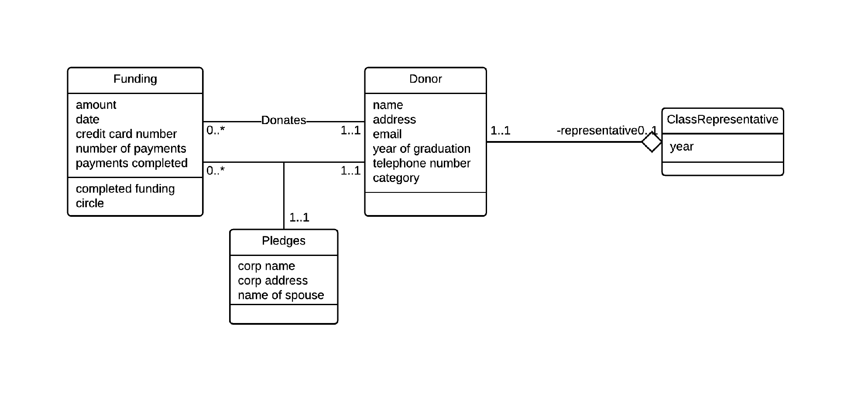

*Figure 1: University Annual Fund UML Diagram*

Figure 1 shows our UML diagram for our implementation. All in all, we have 4 classes representing 5 real tables. A donor table to represent the data of all potential donors, a class representative table to represent all class representatives along with their assigned class / batch, a funding table to represent all the funds that are received, and their payment method. A donates and pledges table to represent donors pledging and donating funds. The pledges table contains additional information for “matchers”.

Shown also in Figure 1, A donor is related to funding, as the purpose of this database is to keep track of donations and pledges of donors. The donor and funding table are related through a join table, appropriately named “Donates” and “Pledges”. This allows the donor to have multiple fundings. The “ClassRepresentative” table aggregates a donor in its class.

The diagram captures the following client specified constraints:

* batch / class → class representative
* donation amount → donation circle

The diagram also captures the following constraints: